**ST BENEDICT’S COLLEGE**

**INFORMATION TECHNOLOGY  
GRADE 11**

**PRACTICAL EXAM**

**NOVEMBER 2011**

**TIME: 3 ½ HOURS MARKS: 120  
EXAMINER: MRS D KENCH**

**SURNAME:**

**USERNAME: PASSWORD:**

**INSTRUCTIONS:**

1. Read through the paper and follow all instructions CAREFULLY.
2. Save all your work in the exam folder provided.
3. Ensure that your name is on your program as the first line.
4. For SQL you will need to migrate the database first.
5. Run each query in Netbeans before you paste your answers in the answer sheet.
6. Use your time wisely.

**QUESTION 1 JAVA PROGRAMMING**

**Quiz**

An IT teacher wants to create a quiz that will test her students to see if they have learnt their theory. She has created a text file called **Quiz.txt** that stores the question, the answer and the section that the question relates to. i.e. Hardware, Software or Programming. When the user runs the test, they will select either Hardware, Software or Programming questions.

A data in the text file is shown below:

Name the component that is primary memory but is powered by a small battery.#CMOS#Hardware

What is the name of the data structure that can store elements of the same type.#Array#Programming

Give the name of the programming structure to repeat an instruction a fixed number of times.#For loop#Programming

True or False. A while loop can never be infinite.#False#Programming

True or False. A global variable can be accessed throughout a program.#True#Programming

A(n) ---------- is a variable that never changes.#Constant#Programming

True or False. An alias is the cute girl on TV who does amazing karate moves.#False#Programming

Another word for creating an object is ----------.#Instantiation#Programming

A common name for a programming error is a --------.#Bug#Programming

A(n) -------- translates source code line by line.#Interpreter#System Software

Give the common name for malicious code that can damage your computer.#Virus#System Software

Give the name of system software that manages and controls the computer.#Operating System#System Software

A(n) ------- is a signal sent from a device to the CPU to indicate that the device needs servicing.#Interrupt#System Software

----- memory is used to speed up access to slower RAM.#Cache#Hardware

The process of making extra copies of all your important files is called -------.#Backup#System Software

Data ------ is where files are made smaller to take up less space.#Compression#System Software

----- is where an instruction is divided into stages so that the CPU executes an instruction on each clock tick.#Pipelining#Hardware

A device to convert analog signals to digital signals and visa versa.#Modem#Hardware

A type of memory that is used when the computers hard drive is used to simulate RAM.#Virtual#System Software

A user friendly interface that consists of windows, icons, mouse and a pointer. (Give the three letter acronym).#GUI#System Software

A type of printer that uses toner.#Laser#Hardware

An input device that can represent a picture or text on paper digitally.#Scanner#Hardware

A hard disk is divided into ----- and sectors.#Tracks#Hardware

A type of bus that is exclusively used for graphics. (Give the acronym)#AGP#Hardware

The ------- bus transfers data and instructions from the RAM to the CPU.#Data#Hardware

An optical medium that can store about 700 MB.#CD#Hardware

The program counter on the CPU is an example of a ------.#Register#Hardware

Games are the only types of application packages#False#System Software

1. **User** class
   1. Create a **User** class to store the user’s name and the number of questions they have answered correctly, and the total number of questions they have answered. Call these fields **name**, **quesCorrect** and **totalQues**. Use suitable types for these fields and make sure these fields are not accessible outside the class. (3)
   2. Code a constructor that will accept a parameter for the user’s name. Assign the other two fields to 0 as the user has not answered any questions. (3)
   3. Add accessor and mutator methods to access and change the values of all the fields. (4)
   4. Add a method called **calcResult** to work out and return the percentage that the user has scored correct using the **quesCorrect** and **totalQues** fields. For example of the have 3 correct questions out of a total of 4 questions, their result is 75% correct answers. (4)
   5. Code a **toString** method to display all the fields separated by tabs. (3)

**[17]**

1. **Question** class
   1. Code a **Question** class to store the question, answer and category using suitable types. (3)
   2. Code a constructor method with parameters to assign values to the three fields. (3)
   3. Code accessor methods for all three fields. (2)
   4. Code a **toString** method to display all the fields, one line underneath each other. (4)

**[12]**

1. **QuestionArray** class
   1. Code a **QuestionArray** class to store 50 question objects. Include a variable called size to remember the number of elements in the array. (3)
   2. Code a constructor to instantiate array of **Questions** using the text file The constructor must use a parameter to select only Hardware, Software or Programming questions. Update the variable called size to reflect the number of elements in the array. (10)
   3. Add a **getSize** method to return the value of size. (1)
   4. Add a method called **shuffle** to randomly rearrange the questions in the array. (10)
   5. Add a method called **getQuestion** to return a particular question, answer and category given the question number in the array. (4)
   6. Add a **toString** method to display the **QuestionArray** on the screen. (4)

**[29]**

1. Code a **GUI** class that will instantiate a **QuestionArray** object and interact with the user. Randomly generate whether to create a Hardware, Software or Programming quiz. Pass this value to the constructor as a parameter. (3)
   1. Add code to call the **shuffle** method to change the order of the questions. (1)
   2. Add code to input the user’s name and then instantiate a **User** object using the name of the user. (2)
   3. Display the number of questions in the array by calling the **getSize** method (3c) and then ask the user to choose a question ranging from 1 to the size value. For example, if the array has 10 questions, inform the user to enter a number from 1 to 10. You may assume that the user will only enter the same question number once and that the user follows the instructions. (4)
   4. Using the **getQuestion** method (3e), display the question and allow the user to enter the answer. Add 1 to the **totQues** field using the method you wrote in 1c to show the user has answered another question. If the answer is correct update the user’s **quesCorrect** field to be one more using the method you wrote in 1c. (6)
   5. Add code to allow the user to answer more than one question. You may use the GUI interface and add a component like a button, or code a loop. (2)
   6. Add code to display the user’s final result using the **calcResult** method. (2)

**[20]**

**TOTAL 80**

**QUESTION 2 SQL**

A new driving School called Top Gear has a list of all students who have enrolled for driving lessons. Their details are stored in a table called **Student** in a database named **Top-Gear Driving DB**. Each student has an autonumbered ID field, their first and last name. phone number, suburb where they live, date of birth and their gender. The table also stores the name of the instructor who has been assigned to them, the number of lessons booked and how much they have paid to date.

Details of the design of the Student table is show below.

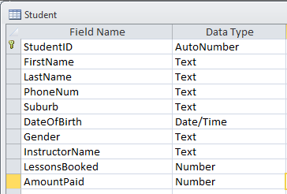

The data that is stored in the table is as follows:

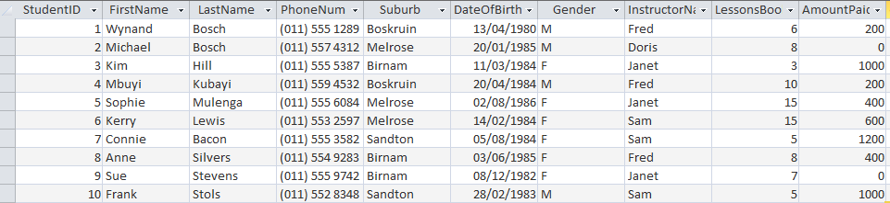

Write SQL statements for the following queries. Paste your answers into the word file called **SQL Answers** found on your T: drive.

* Migrate the database into mySQL.
* Open Netbeans and connect to the database.
* Run in each of the queries in Netbeans before you paste them to answer file.

1. List all the students sorted according to last name, then first name. (3)
2. Find all students who have 555 in their telephone number. List only their first name and phone number. (4)
3. List all the female students who have not paid. Display their last name only. (5)
4. Insert a new student using your details. Assign Doris as your instructor with 4 lessons booked and R200 paid. (4)
5. Delete Wynand Bosch. (3)
6. Count how many students are allocated to each instructor. Display the instructors name and their number of students. (6)
7. Each lesson costs R200. Display each student and the amount they need still need to pay if they have not paid for all their lessons. For example Kerry Lewis has booked 15 lessons but has only paid R600. She still owes R200 x 15 = R3000 less R600 to be R2400. (7)
8. Calculate the age of each student and sort from youngest to oldest. (5)
9. Display the top three students who have booked the most lessons. (3)

**TOTAL 40**